openclaw安装以及基本配置
官网https://openclaw.ai
powershell一键安装命令iwr -useb https://openclaw.ai/install.ps1 | iex
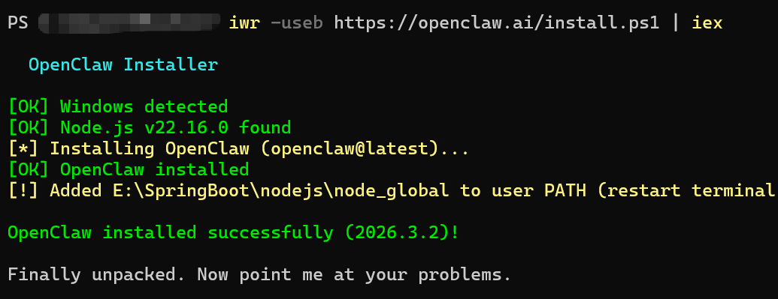
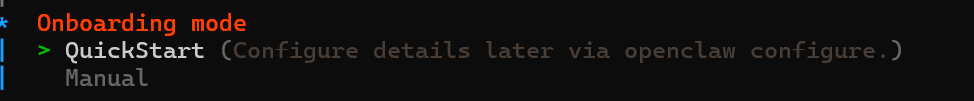
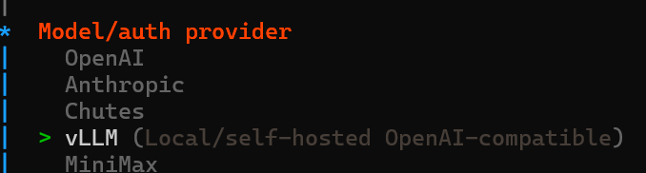
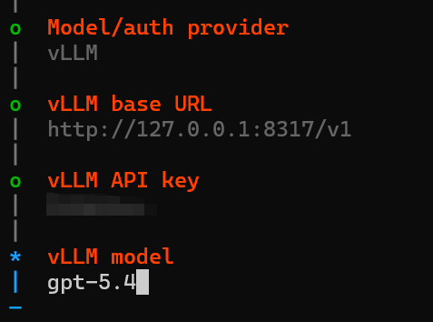
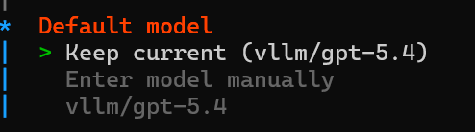
2、接入飞书
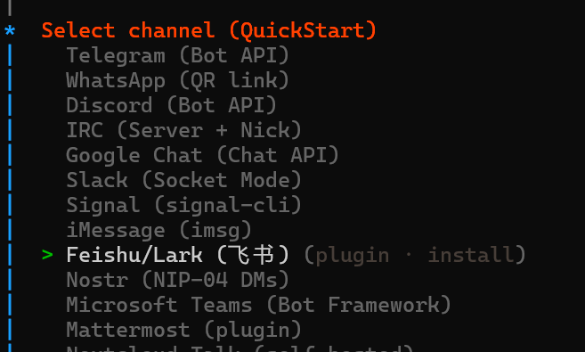
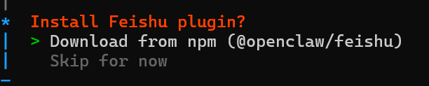
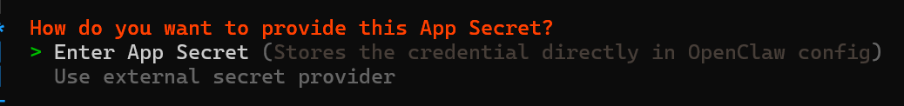
注册飞书账号https://open.feishu.cn
官网教程https://docs.openclaw.ai/channels/feishu
进入开发者后台
创建应用
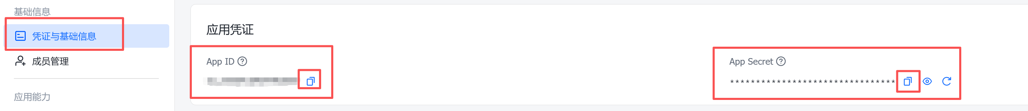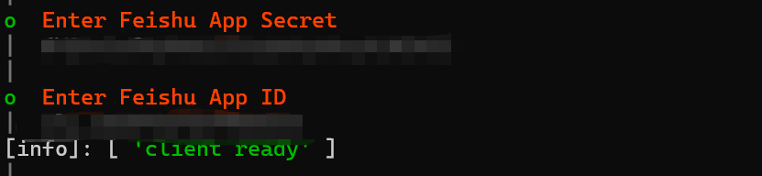
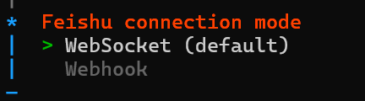
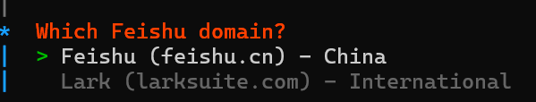
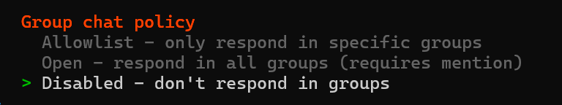
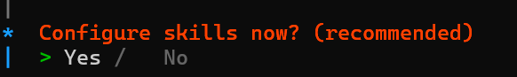
按空格选中
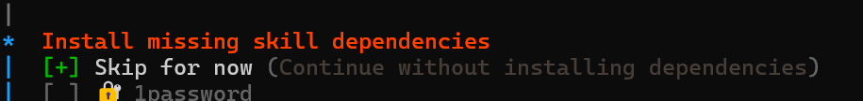
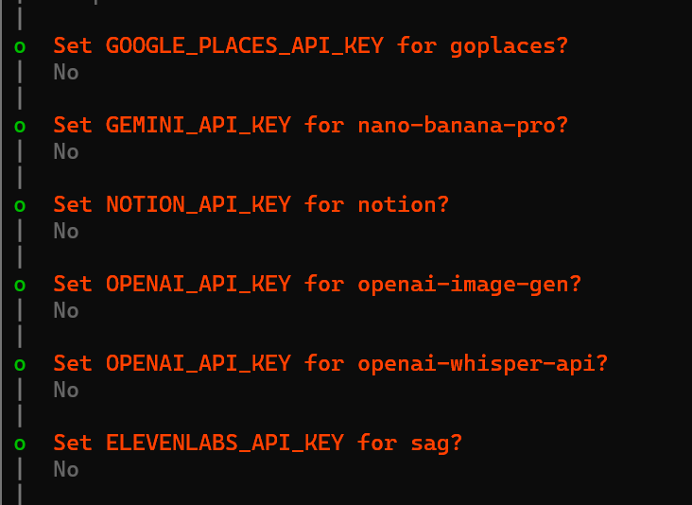
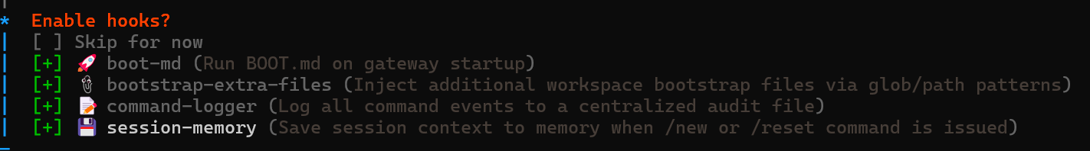
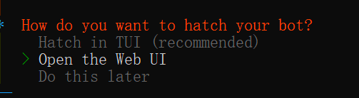
找到C:\Users\’你的用户名’\.openclaw\openclaw.json
记事本打开，找到messaging修改为full，保存
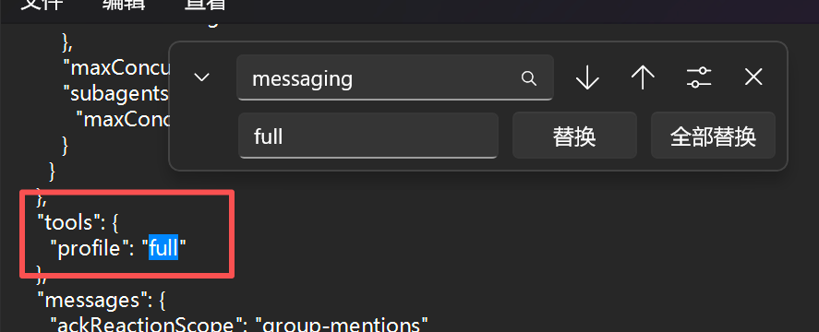
Powershell运行openclaw gateway重启


回到飞书开发者后台
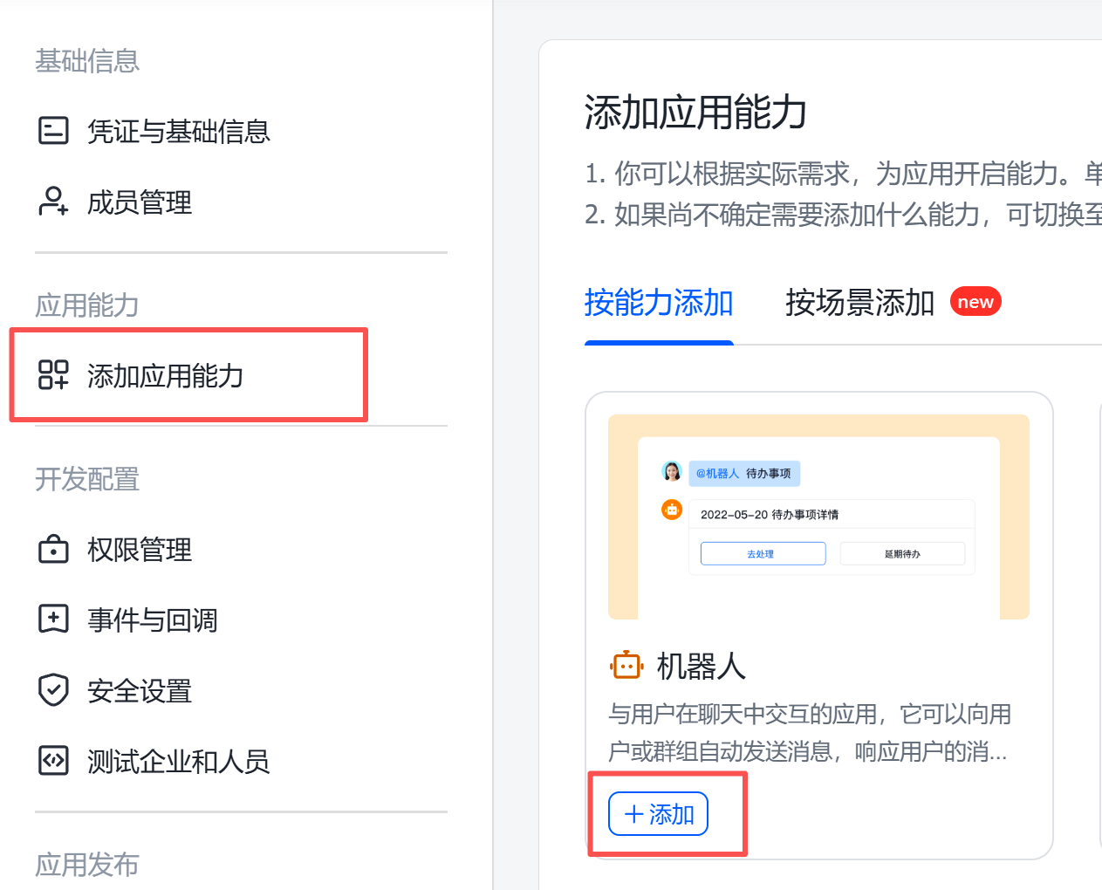

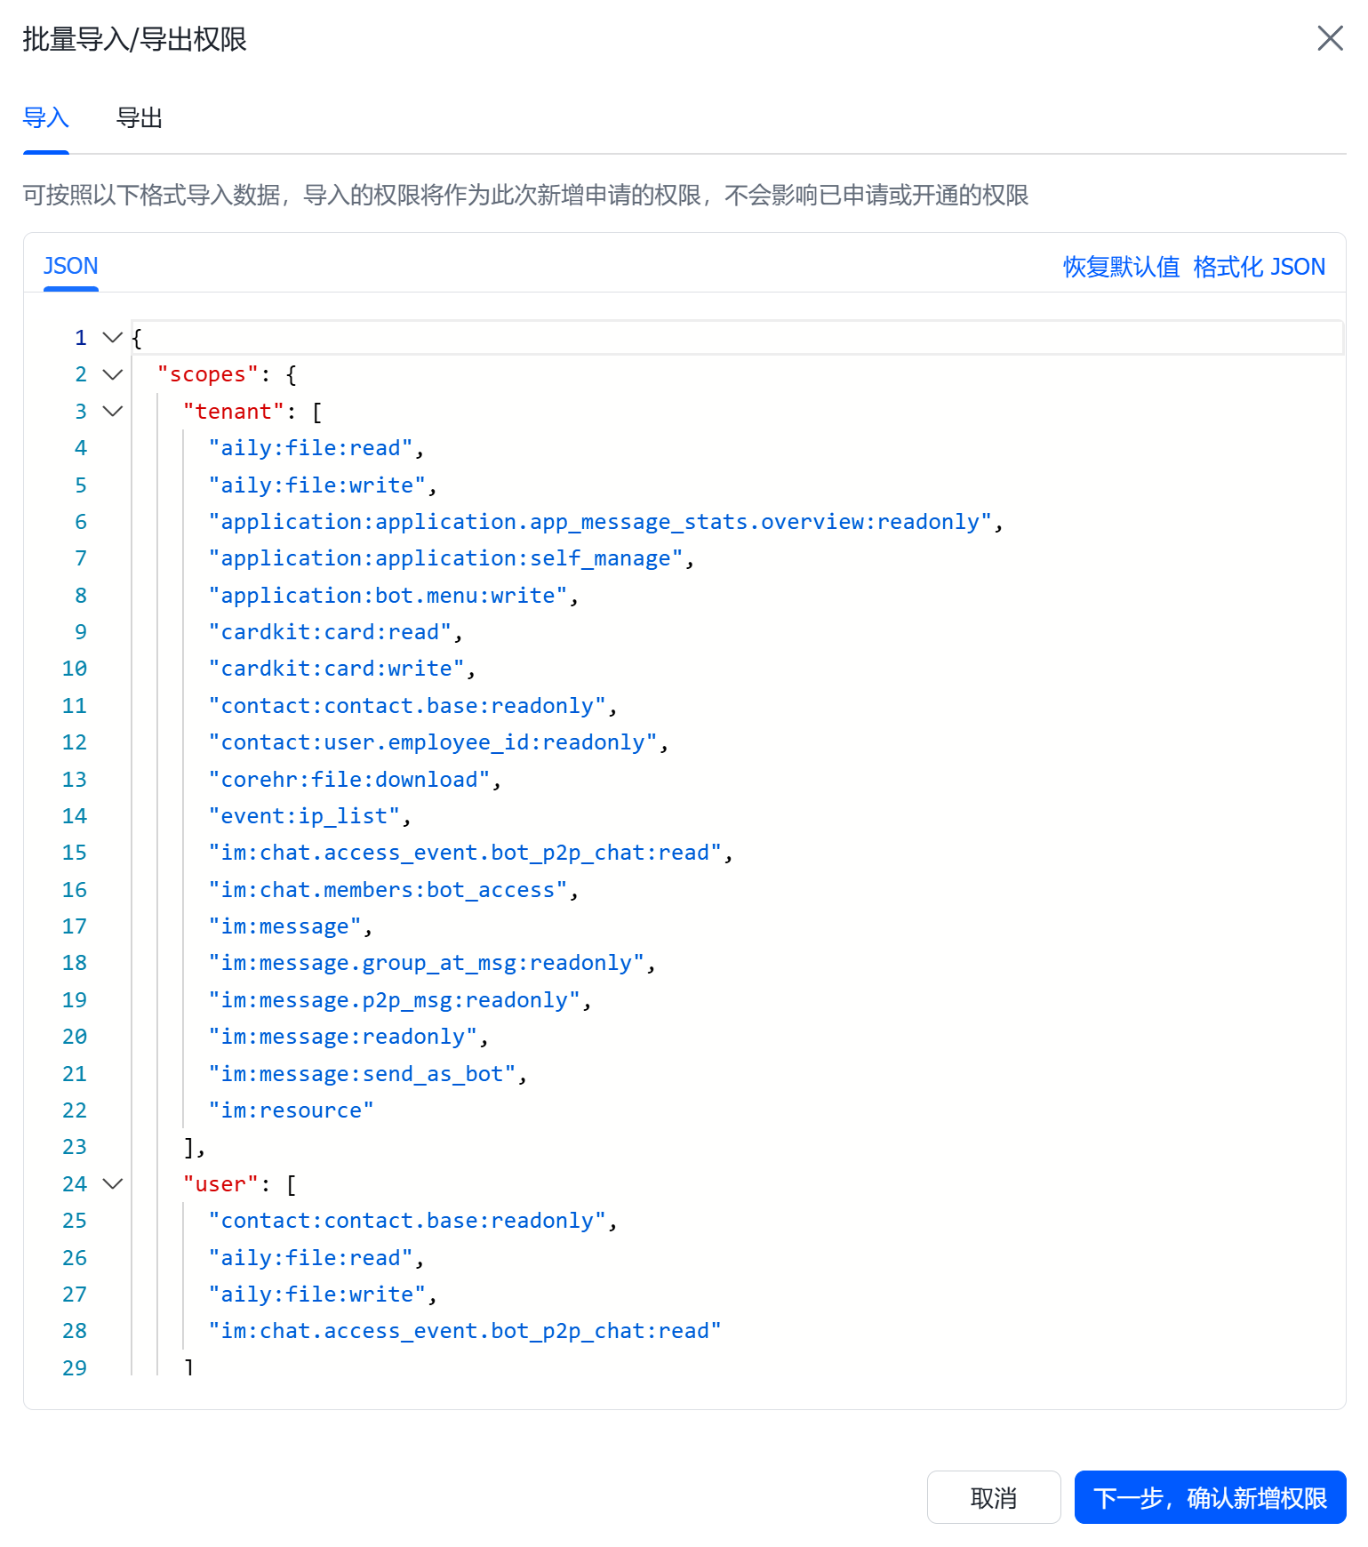

{
"scopes": {
"tenant": [
"aily:file:read",
"aily:file:write",
"application:application.app_message_stats.overview:readonly",
"application:application:self_manage",
"application:bot.menu:write",
"cardkit:card:read",
"cardkit:card:write",
"contact:contact.base:readonly",
"contact:user.employee_id:readonly",
"corehr:file:download",
"event:ip_list",
"im:chat.access_event.bot_p2p_chat:read",
"im:chat.members:bot_access",
"im:message",
"im:message.group_at_msg:readonly",
"im:message.p2p_msg:readonly",
"im:message:readonly",
"im:message:send_as_bot",
"im:resource"
],
"user": [
"contact:contact.base:readonly",
"aily:file:read",
"aily:file:write",
"im:chat.access_event.bot_p2p_chat:read"
]
}
}
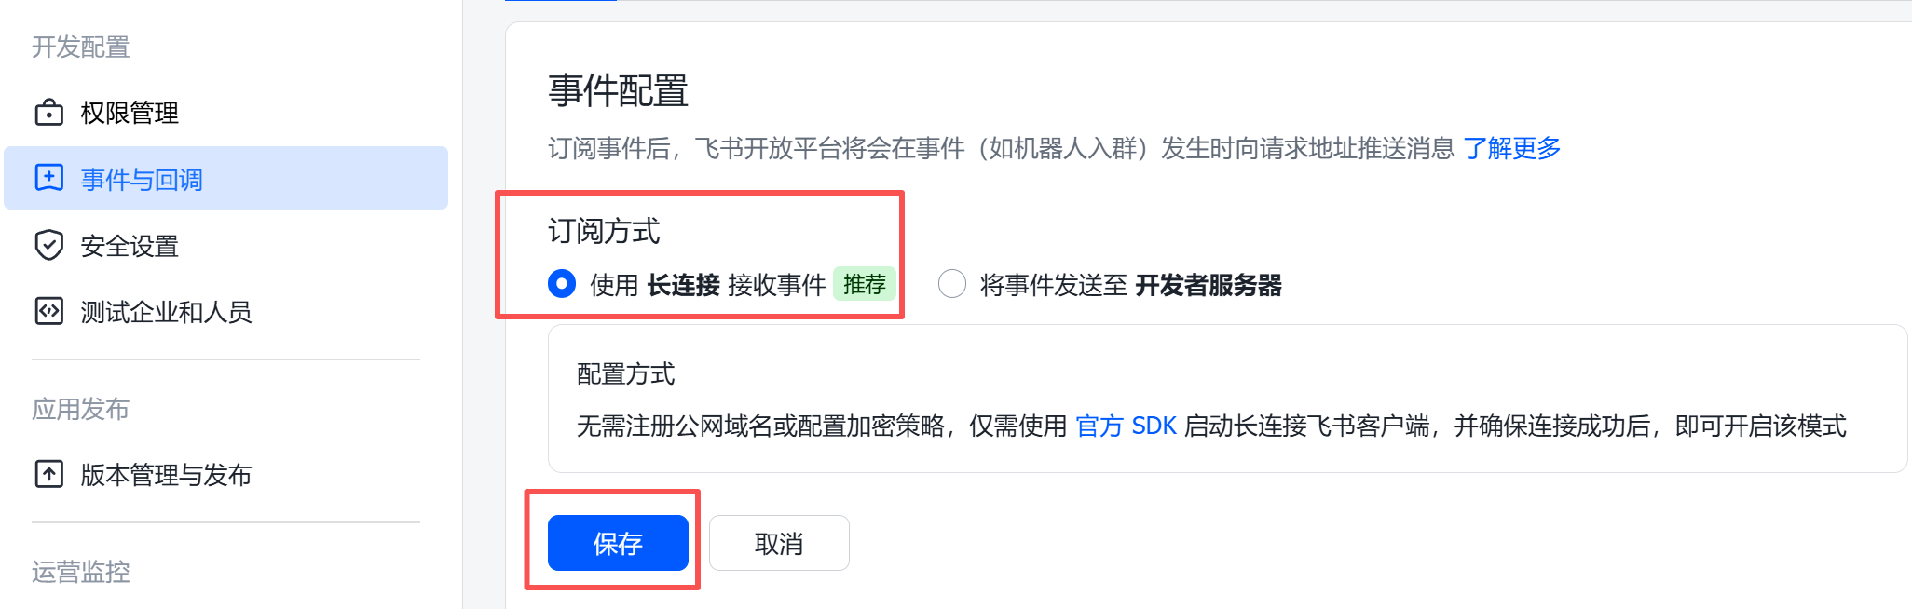
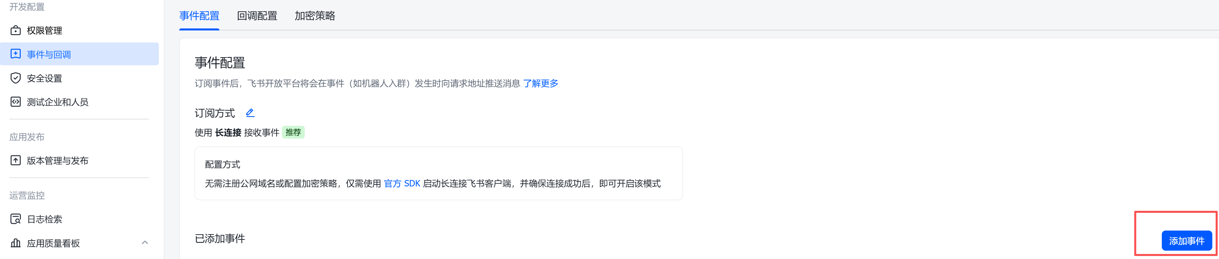
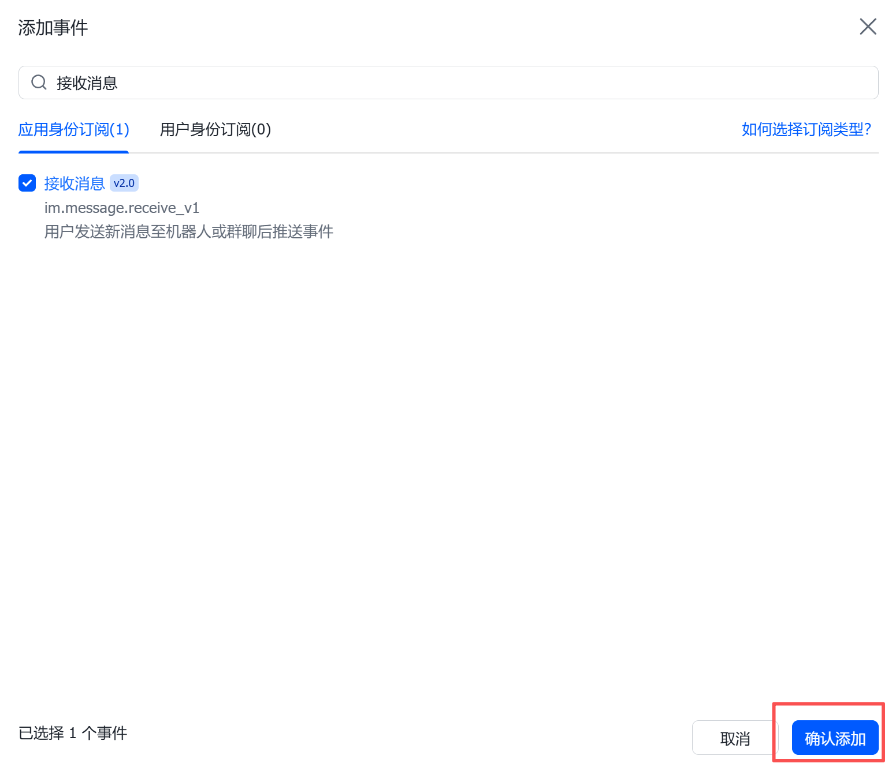

来到飞书客户端

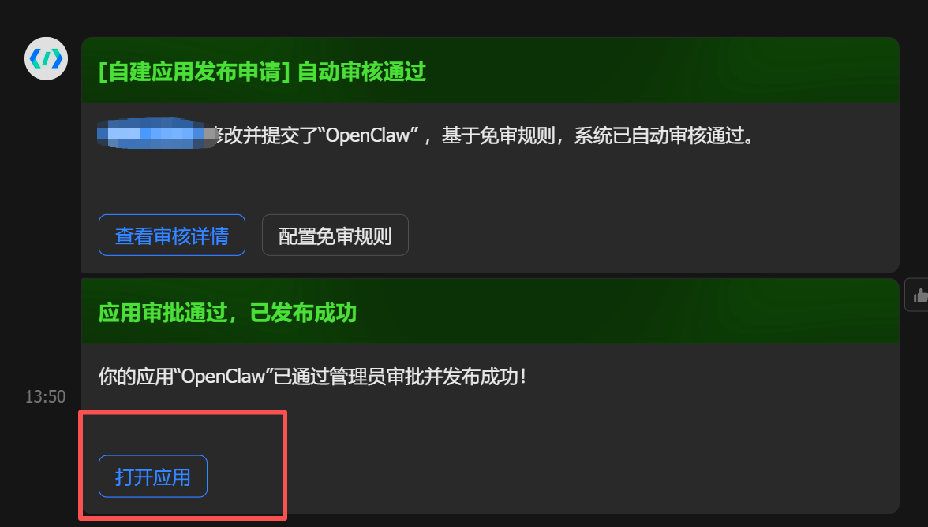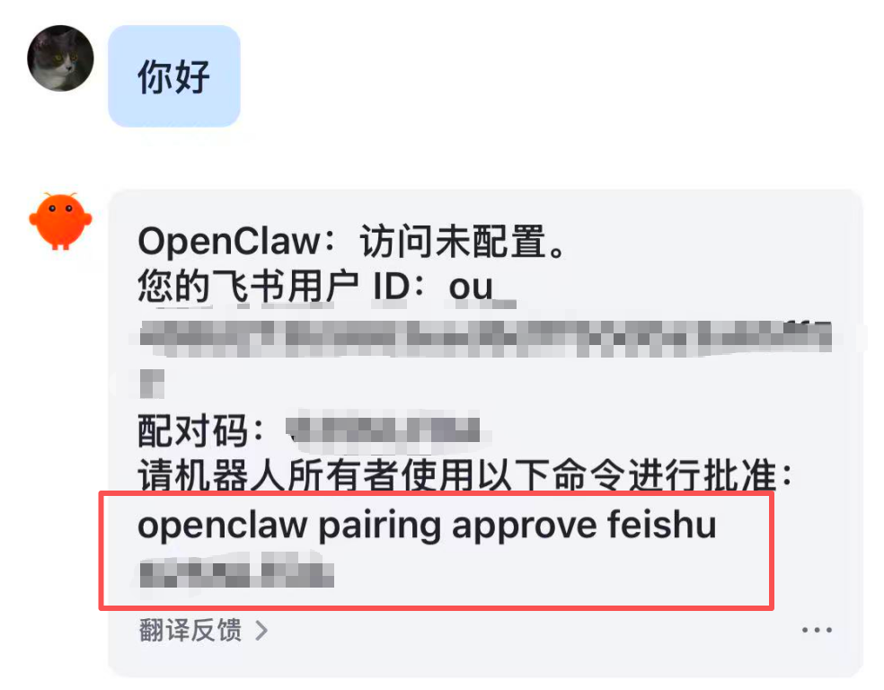
打开powershell，运行上方命令
